

Digital Tracking Methods System

SYSTEM DOCUMENTATION

SUBMITTED BY,
HELLEN MURIUKI
DSE-01-8599/2024

A SYSTEM DOCUMENTATION SUBMITTED IN PARTIAL FULFILMENT FOR THE AWARD OF DIPLOMA IN SOFTWARE ENGINEERING BY ZETECH UNIVERSITY

DECEMBER 2025

SECTION 1: DECLARATION
I Hellen Muriuki Declare that this document has never been used anywhere else

Student Name: ____Hellen Muriuki________________________ Sign: _________________ Date: __________
Supervisor Name: _________________________ Sign: _________________ Date: __________

SECTION 2: DEDICATION

SECTION 3: ABSTRACT

SECTION 4: DEFINITION OF KEY TERMS
Module-Independent units that can be used to construct a more complex structure.

SECTION 5: ABBREVIATIONS AND ACRONYMS

HTML – Hyper Text Mark Up Language
SQL – Structured Query Language

SECTION 6: LIST OF FIGURES

SECTION 6: LIST OF TABLES

Table of Contents
i
Digital Tracking Methods System i
SECTION 1: DECLARATION 2
SECTION 2: DEDICATION 3
SECTION 3: ABSTRACT 4
SECTION 4: DEFINITION OF KEY TERMS 5
SECTION 5: ABBREVIATIONS AND ACRONYMS i
SECTION 6: LIST OF FIGURES ii
SECTION 6: LIST OF TABLES iii
SECTION 7: TABLE OF CONTENTS iv
SECTION 8: CHAPTER ONE: PROJECT PLANNING AND ANALYSIS 1
(WORKPLAN) 1
References 1
Chopra, S., & Meindl, P. (2019). Supply Chain Management: Strategy, Planning, and Operation (7th ed.). Pearson. 1
Laudon, K. C., & Laudon, J. P. (2022). Management Information Systems: Managing the Digital Firm (17th ed.). Pearson. 1
Turban, E., Pollard, C., & Wood, G. (2018). Information Technology for Management: On-Demand Strategies for Performance, Growth and Sustainability. Wiley. 1
Heizer, J., Render, B., & Munson, C. (2020). Operations Management: Sustainability and Supply Chain Management (13th ed.). Pearson 1
SECTION 9: CHAPTER TWO: DESIGN AND MODELING 2
SECTION 10: CHAPTER THREE: SYSTEM IMPLEMENTATION 3
(DEVELOPMENT, TESTING AND DEPLOYMENT) 3
SECTION 11: CHAPTER FOUR: CONCLUSION AND RECOMMENDATION 5
SECTION 12: REFERENCES 6

SECTION 8: CHAPTER ONE: PROJECT PLANNING AND ANALYSIS

(WORKPLAN)
  - Statement of Problem
Currently, Haraka Rider Services relies on manual tracking through phone calls, handwritten logs, and SMS. This has led to delayed deliveries, misplaced packages, and lack of proof of service. These inefficiencies reduce customer trust, lower rider accountability, and affect the business reputation. The absence of a proper tracking system makes it difficult to monitor rider performance and ensure customer satisfaction.

References

Chopra, S., & Meindl, P. (2019). Supply Chain Management: Strategy, Planning, and Operation (7th ed.). Pearson.

Laudon, K. C., & Laudon, J. P. (2022). Management Information Systems: Managing the Digital Firm (17th ed.). Pearson.

Turban, E., Pollard, C., & Wood, G. (2018). Information Technology for Management: On-Demand Strategies for Performance, Growth and Sustainability. Wiley.

Heizer, J., Render, B., & Munson, C. (2020). Operations Management: Sustainability and Supply Chain Management (13th ed.). Pearson

  - Study Justification
Currently, Haraka Rider Services relies on manual tracking through phone calls, handwritten logs, and SMS. This has led to delayed deliveries, misplaced packages, and lack of proof of service. These inefficiencies reduce customer trust, lower rider accountability, and affect the business reputation. The absence of a proper tracking system makes it difficult to monitor rider performance and ensure customer satisfaction.

  - System Objectives
    - General Objective
To develop a digital tracking system

    - Specific Objectives
- To develop a task assignment module with rider availability checking
- To integrate real-time delivery updates using a status panel.
- To build a delivery confirmation module with customer verification.
- To create an admin dashboard with delivery logs and reports.

  - Functional Requirements
User | User Activities | Features
Riders | - Receive tasks, confirm delivery | - Rider dashboard
 | - Confirm delivery | - Proof of delivery
Customers | - Request delivery | - Costomer portal
 | - Track status  - Confirm receipt | - Tracking  - Notification
Admin | - Assign tasks  - Monitor delivery  - Manage riders | - Task assignment  - Monitoring tool  - Admin dashboard
1.4
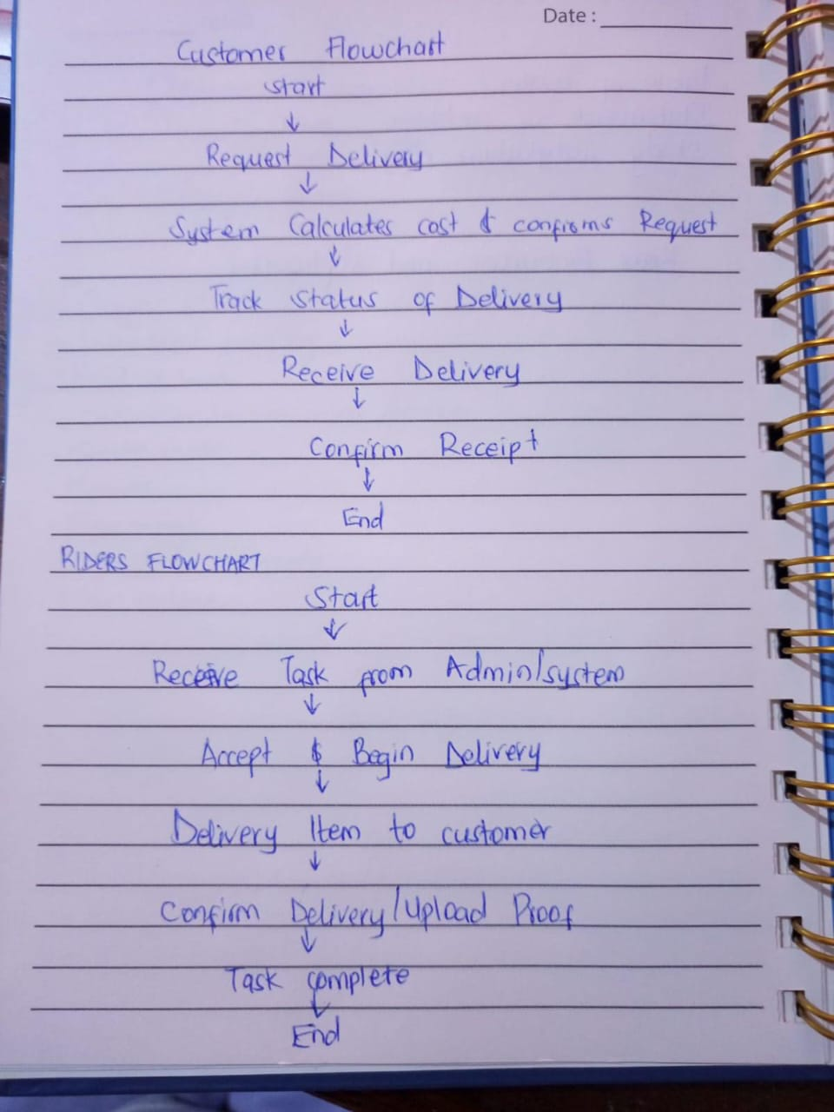

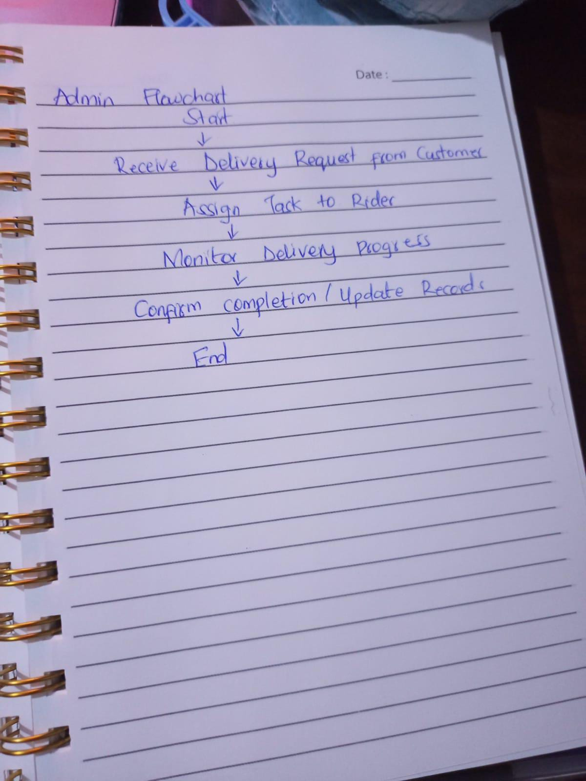

Table 1.4 Functional Requirements Table

  - Breakdown of Tools & Resources to Be Used
Hardware
- Laptop (Specifications)
- Scanner

Software
- Python (IDE - Visual Studio)
- Mysql, SQL
- Ms office - Documentation
- Java (IDE – Netbeans)
- Xamp server
- Github
- API’s
- Web-browser - Google
- PHP, HTML, CSS

1.6 Project Schedule Breakdown
 | PROJECT MILESTONES
WEEKS | Project Planning & Analysis  (System Documentation: Coverpage & Chapter One) | Project Design & Modeling  (System Documentation Chapter Two) | Project Development & Testing  (System Documentation Chapter Three) | Project Deployment  (System Documentation Chapter Three) | Final Touches of System Documentation  (Preliminary Pages, Chapter Four & References) | Project Presentation
1-5 Sept
8-12 Sept
15-19 Sept
22-26 Sept
29- 3 Oct
6-10 Oct
13 – 17 Oct
20-31 Oct
3- 7 Nov
10-14 Nov
17-21 Nov
24-28 Nov
28 Nov
Table 1.6 Project Schedule Breakdown

SECTION 9: CHAPTER TWO: DESIGN AND MODELING
Transfer all the diagrams you used to design your system during milestone 3, to this chapter. Explain each diagram, have the diagram below the explanation, and a caption below the diagram

2.1 Introduction to Modelling
A paragraph telling the reader that in this chapter they’ll find designs and models that you drew to help you visualize the system before you started the development work, and the benefit you got from modelling your system before developing.

2.2 User Interface Models
Diagrams of all the forms, pages, reports, windows, dialog boxes, interaction panels for users that you hand-sketched to visualize how they would look like before developing.
Organize them into subheadings e.g. 2.2.1 Login Page Design, 2.2.2 Sign Up Form Design, 2.2.3 Products Page Design. In each subheading, have the hand-sketched / Figma-sketched design of that UI, and a caption underneath it e.g. Fig 2.2.1 Login Page Design, Hand-Sketched.

2.3 Logic Models
Diagrams of all the process architecture diagrams that you sketched to visualize how the system will work e.g. flowcharts, class diagrams, sequence diagrams, data flow diagrams, decision trees, etc..
Organize them into subheadings e.g. 2.3.1 Login Process Flowchart, 2.3.2 Purchase/Checkout Process Flowchart, 2.3.3 Class Diagram for the System, 2.3.4 From Enquiry Making to Enquiry Reply Flowchart
In each subheading, have the hand-sketched (or if you’ve used a drawing tool) design of that diagram, and a caption underneath the diagram

SECTION 10: CHAPTER THREE: SYSTEM IMPLEMENTATION

(DEVELOPMENT, TESTING AND DEPLOYMENT)

This is where you report on your development journey e.g. from when you downloaded your IDEs, and coding, to implementing your database to deploying your system

3.1 Introduction
A paragraph telling the reader what they expect to see in this chapter – a journey of your development

3.2 User Interface Development
Your system has two sides – the user side (where different users can interact with the system) and the logic side.
Under this section you will screenshot all the User Interfaces you have built (login pages, sign up forms, report page, dashboard, etc.) and the code for them if you built them from scratch, e.g. a screenshot of the html and css code for sign up form.
Organize them into subheadings e.g. 3.2.1 Login Page Development (under this section, a brief explanation of what it’s been built for, a screenshot of the page and a caption underneath it, screenshots of its html and css code used to develop it, and captions underneath every screenshot)

3.3 Logic Development
Your system has two sides – the user side (where different users can interact with the system) and the logic side. The logic side is how the system is performing activities using data e.g. login validation, processing checkout and generating a receipt, storing data into database, retrieving products from DB and showing them on a certain page. This is called logic.
Under this section you will screenshot all the Codes or Simulations that handle different processes/activities. Organize them into subheadings e.g. 3.3.1 Login Validation Code (herein, explain in brief how the system handles login, take screenshots of the login validation code, and caption it)
3.4 Testing
Detail out what actions you took to test whether different features of your system are working. And corrections you made to different parts to ensure that they are working as planned.

3.5 Deployment
Mention on what platform have you deployed your system (e.g. if it’s a website, what web hosting platform did you use – and copy paste a link to your website, if it’s an android application – the process of putting up your app on Google Playstore.). Essentially, detail out the process of how you transformed your project into a form that can be run/installed by anybody.

SECTION 11: CHAPTER FOUR: CONCLUSION AND RECOMMENDATION
4.1 Conclusion
A paragraph summarizing chapter one, two and three. And finish by telling the reader what new things you learnt during the entire time developing your project, and challenges faced.

4.2 Recommendation
Here, speak as if addressing another developer of the same project you’ve been working on. Suggest to him/her things that they can do to improve the system if they so choose to pick it up and enhance it. E.g. if you created an e-receipt for customers, suggest to him/her to consider integrating a physical receipt printer since some customers would prefer that and also you couldn’t implement that because you didn’t have the budget for a printer. If your system is a staff clock-in-and-out system and in your system a staff has to type in their staff number into the system, suggest to the developer what better technologies he/she can use to enhance that specific part e.g. biometric or swipe-card, maybe since you did not have the budget to buy those devices and/or didn’t have the technical skills for that. Or if for payment your system is using Pay-After-Delivery, suggest to him/her to consider integrating with MPESA or Bank Card for pre-delivery payments.
NB: Recommendation is not an excuse for a NOT WORKING system, e.g. it is not saying that your system can’t store any data because you didn’t have the time to implement a database, No. It is a suggestion for how your ALREADY WORKING SYSTEM (with the lower technologies you’ve used) can be MADE BETTER, with HIGHER/BETTER TECHNOLOGIES. E.g. you used MySQL to store structured data, suggest for them to use a NO-SQL approach to store non-structured data like customer feedback and product reviews.

SECTION 12: REFERENCES
A list of all the websites, articles, books, YouTube channels, AI Conversations (copy link address) that helped you during your project.
Format them in APA7 format, in alphabetical order.
A guide on referencing from web articles/tutorials: https://libraryguides.vu.edu.au/apa-referencing/7Webpages (see in-black-box)
A guide on referencing from social media articles: https://libraryguides.vu.edu.au/apa-referencing/7SocialMedia (see in-black-box)
A guide on referencing from conversations you had with AI e.g. ChatGPT: https://libraryguides.vu.edu.au/apa-referencing/generativeAI (scroll to end of page)

Done with references, now go back to PRELIMINARY PAGES (pages before chapter one), and fill those pages

